**MINI PROJECT**

**(2020-21)**

**TELE CHAT APPLICATION**

**MID-TERM REPORT**



**Institute of Engineering & Technology**

**Submitted by**

**Shivam Shukla (181500671)**

**Ayush Agrawal (181500167)**

***Supervised By: -***

**Mrs. Harvinder Kaur Mam**

**Abstract**

ANDROID APP DEVELOPMENT were the main objective of this training. To develop a Android application there are several programming languages that are in use. Some of them are only used for the frontend and backend design of the software. For example, XML, JavaScript, PHP.

If we develop Android application that is very useful for us because we can access it from anywhere of the world. It is very helpful for our daily life. That is why I choose subject of my report is "ANDROID APP DEVELOPMENT".

**Table of Contents**

**CHAPTER**

**CHAPTER 1: INTRODUCTION**

1.1 Introduction

1.2To save the time and resources

1.3 To reduce the work load

1.4 To make the app user friendly

1.5 Motivation

**CHAPTER 2: IT services offered**

2.1 App design & developmen**t**

2.2 Android Technical Support

**CHAPGTER3: Introduction to the Development tool “Android Studio”**

**CHAPTER4: Objective**

**CHAPTER 5: Software Requirement Specification**

5.1 Introduction Purpose

5.2 Overall Description

**CHAPTE6: Progress**

**CHAPTER 7: Creating Our Android app: Displaying “Tele Chat app”**

**CHAPTER 8: REFERENCE**

**1.INTRODUCTION**

**1.1 Introduction**

As the world is going is going digital it’s a necessity now days to bring good apps. We developed and Music Player app for listening a good and top music's. Technology used in this app was XML, JAVASCRIPT

Some functionalities were:

**. Login option.**

**. Privacy.**

**. Easy to use.**

**1.2To save the time and resources**

You just need to download an application from play store and by just clicking few buttons you are in inside of app.

**1.3 To reduce the work load**

As people now days are busy in their own works, it will help them save some time for themselves and they can spend it with something they love to do.

**1.4 To make the app user friendly**

The app was developed keeping in mind for all types of people so that each and every one can use it with ease.

**1.5 Motivation**

In desktop base android app creating system is easy to understand. Since we all are accept training it seems to me, we all are beginner and primary level to learn app development, so it is easy and interesting to learn and create. Also, technologies used are interesting and easy to build a project by fully XML, JAVASCIPT.

**2. IT services offered**

**2.1 App design & develop**

Having you're App designed and built professionally will improve your company

image and help to enforce your brand.

**2.2 Android Technical Support**

**Technologies Languages**

PHP, XML, JAVASCRIPT

**Android app development platform**

Android Studio

Virtual device

**Server platform**

windows

**3. Introduction to the Development tool “Android Studio”**

Android Studio is the official integrated development environment (IDE) for Android platform development. Android Studio is freely available under the apache license. Android Studio is designed specifically for Android development. Android application development can be started on either of the following operating systems –

Microsoft® Windows® 8/7/Vista/2003 (32 or 64-bit).

Mac® OS X® 10.8.5 or higher, up to 10.9 (Mavericks).

GNOME or KDE desktop. All the required tools to develop Android applications are open source and can be downloaded from the Web. Following is the list of software's that is needed before starting Android application programming.

Java JDK5 or later version Java Runtime Environment (JRE) 6

Android Studio.

**4.Objective**

Promote the highest levels of human aspiration and artistic integrity through the composition, documentation, and performance of music.

2) Develop an analytical, creative, and intuitive understanding of music as a cultural language.

3) Afford students opportunities for cultural and aesthetic experiences through active participation in music, enhance their understanding and appreciation of the arts, and foster interaction between music and the liberal arts.

4) Enrich the campus and the region through concerts, workshops, and other public events, and provide opportunities for traditional and contemporary musical expression by students, faculty, guest artists, and members of the community.

**5. Software Requirement Specification**

**5.1 Introduction Purpose**

Tele Chat app is an android application that aims at providing a best thing. It comprehensively covers details of various aspects of Privacy issues. This document provides all the required specifications of the android application.

**Scope**

The application contains following in-built features-

1. Easy to use.

**5.2 Overall Description**

**5.2.1 Product Perspective Software interface:**

This application will be made using the IDE Android Studio with Java and XML. It shall use SQLite at the database level to store details. It shall require Android API 17.

Memory Constraints: The application shall run on a system with RAM>2GB.

Communication interface: The user shall interact with the application with the help of graphical screens. The user can select the criteria according to their pets.

**5.2.2 Product Functions**

The application contains following in-built features-

1. The user must create account to view the app.
2. On the basis of the selection of service the results will be shown accordingly.

**5.2.3 User Characteristics**

The user should know how to operate a smart phone with android OS and he should be familiar with the functioning of android applications. He should know how to input data and select options

**6.Progress**

**1.) Part 1 is completed**

Create front page of Tele Chat app

a. Create a login page .

b. Changing background color white to black.

**2.) Part 2 is completed**

Create Second page of Tele Chat app

a. Create a find user page .

b. Also create logout button.

**7. Creating Our Android app: Displaying “TELE CHAT APP ”**

**7.1Coding for Tele Chat App (Screen sort)**

**1.Front page:**

1. MainActivity.java

2.Activity_main.xml

**2.Second page:**

1. MusicActivity.java (for second page)

2.MusicActivity_main.xml

**First page:**

**1.MainActivity.java**

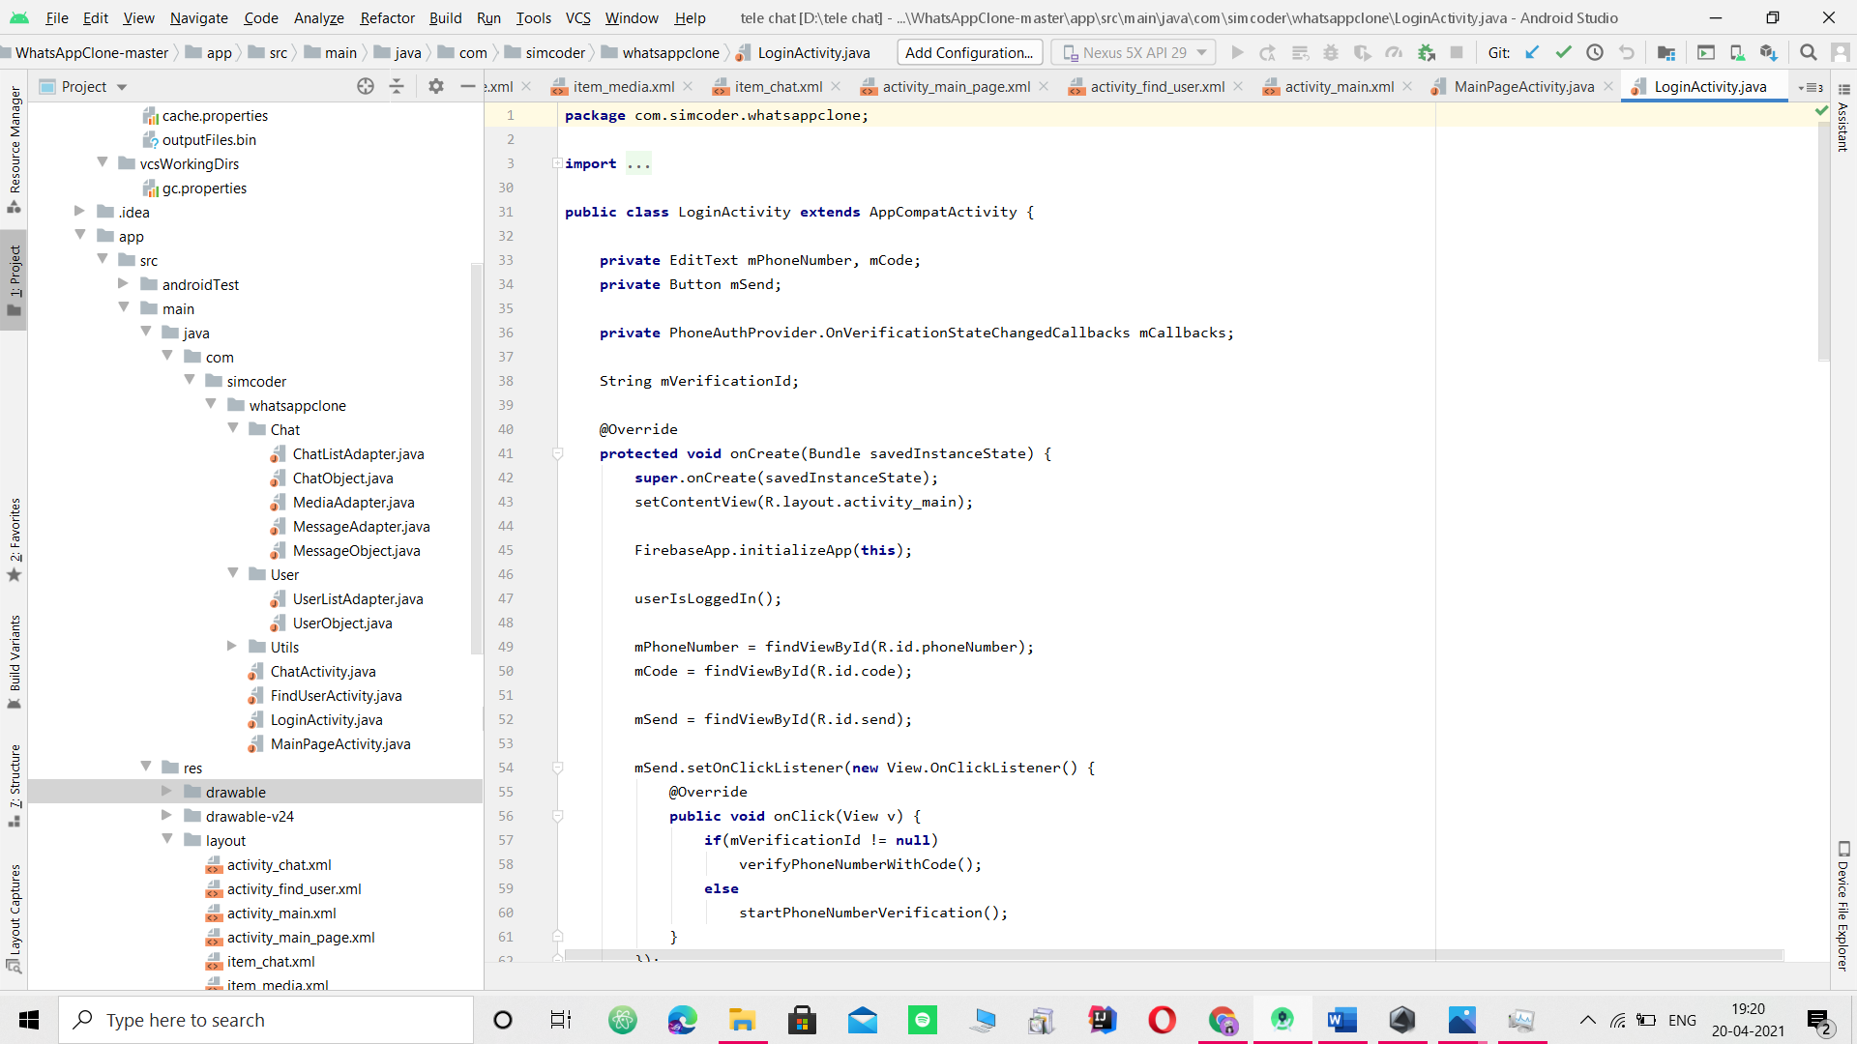

**2.Activity_main.xml**

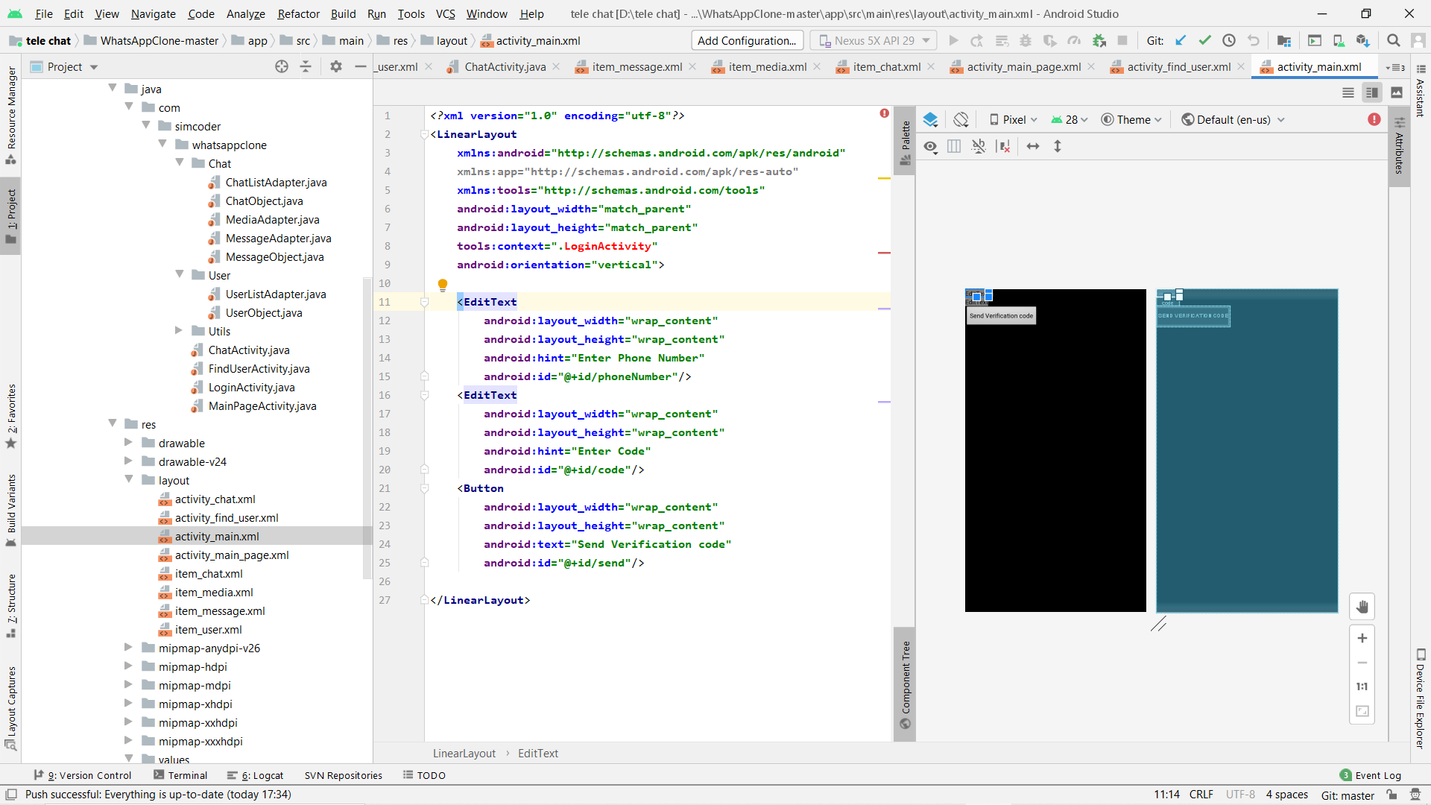

**Second page:**

**1. MusicActivity.java**

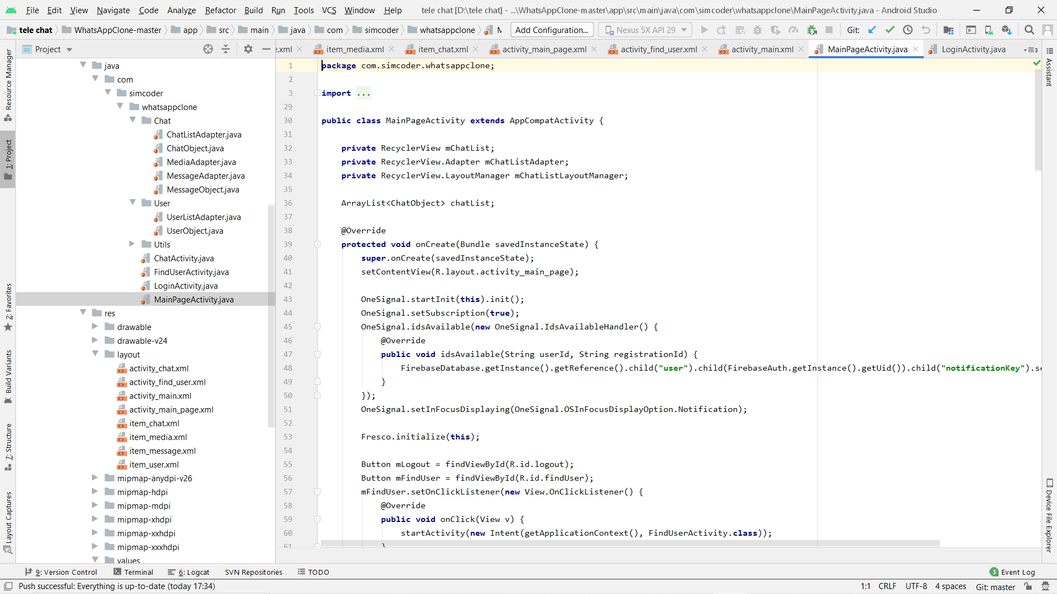

**2.Activity_main.xml**

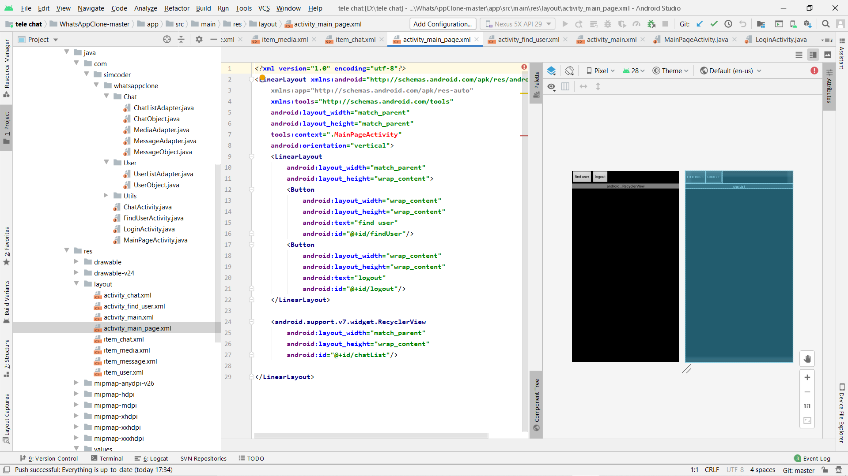

**8. REFERENCE**

* [www.wikipedia.org/](http://www.wikipedia.org/)
* [www.udemy.com/](http://www.udemy.com/)
* [www.google.com/](http://www.google.com/)